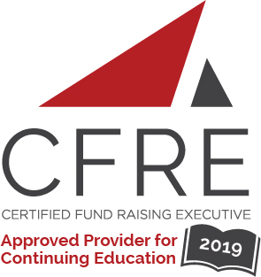
CFRE International has developed this form as a way for you to quickly track (and keep in your files!) the continuing education sessions you have attended. Simply check the boxes next to the sessions you attended. At the end of the conference, add up the total number of hours. Keep this sheet and you will be ready to complete your application form. All of the session slots listed are eligible for continuing education points on your CFRE application for initial certification and/or recertification. Sessions not listed here are not eligible for points.

CONTINUING EDUCATION POINTS TRACKER

Activity Organizer: - ALDE
Title of Activity: - ALDE Webinars
Names of Presenter(s): - Various
Dates and Location: - Various - Online

Date: 26 September, 2019
12:30 pm – 1:30 pm (1.0 pts)
- Donor Visits: Should I Take Someone With Me? Scripting Joint Visits With a Non-Development Colleague - Jeri Pat Gabbert
Date: 24 October, 2019
12:30 pm – 1:30 pm (1.0 pts)
- The Secret Sauce of Direct Mail - Sue and Ron Rescigno

Date: 20 November, 2019
12:30 pm – 1:30 pm (1.0 pts)
- Is Your Team on Fire? How Trust and Loyalty Impact High Performing Teams – Heather Eddy

Date: 12 December, 2019
12:30 pm – 1:30 pm (1.0 pts)
- Donor Advised Funds: Beauty is in the Eye of the Donor - Carlos Byrne

Date: 20 February, 2020
12:30 pm – 1:30 pm (1.0 pts)
- Optimize Your Fundraising: Transform Your Organization One Experiment at a Time - Tim Kachuriak

Date: 16 April, 2020
12:30 pm – 1:30 pm (1.0 pts)
- Discovery — How to Learn About a Donor’s Assets - Cathy Sheffield

Total number of points attained: __________

