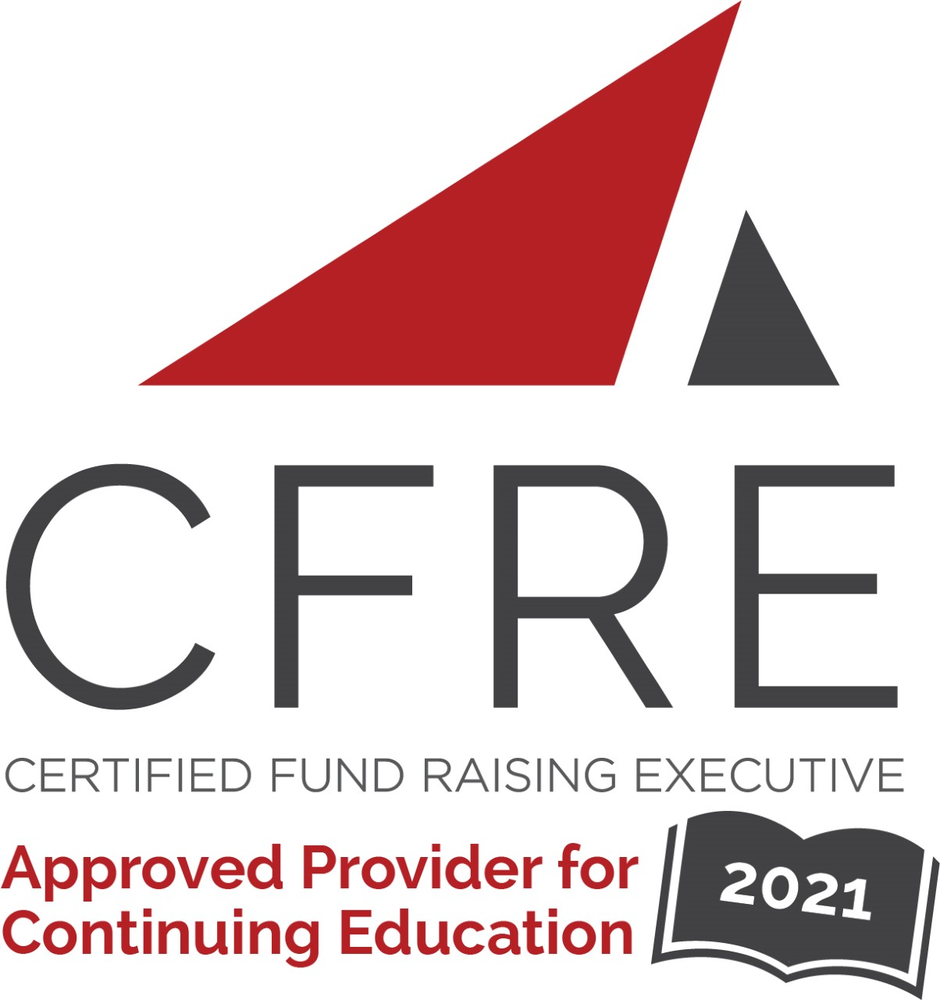  CFRE International has developed this form as a way for you to quickly track (and keep in your files!) the continuing education sessions you have attended. Simply check the boxes next to the sessions you attended. At the end of the conference, add up the total number of hours. Keep this sheet and you will be ready to complete your application form. All of the session slots listed are eligible for continuing education points on your CFRE application for initial certification and/or recertification. Sessions not listed here are not eligible for points. | CONTINUING EDUCATION POINTS TRACKER

Activity Organizer: - ALDE
Title of Activity: - ALDE 2020-2021 Webinars
Names of Presenter(s): - Various
Dates and Location: - Various, Online

Date: 20 August, 2020
12:30 pm – 1:30 pm (1.0 pts)
- Giving Days: One Day to Make a Big Impact - Katie Schroeder and Megan Torkelson

Date: 17 September, 2020
12:30 pm – 1:30 pm (1.0 pts)
- Managing the Ask … Essential Steps When Soliciting Major Donors – Diane Carlson

Date: 22 October, 2020
12:30 pm – 1:30 pm (1.0 pts)
- It Starts With a Solid Fundraising Strategic Plan - Stephen Mally

Date: 12 November, 2020
12:30 pm – 1:30 pm (1.0 pts)
- The House Always Wins! Policies and Procedures That are Understandable, Organized, and Needed for any Organization – Rich Duncan

Date: 10 December, 2020
12:30 pm – 1:30 pm (1.0 pts)
- Donor Retention … Fired Up! – Sue and Ron Rescigno

Date: 18 February, 2021
12:30 pm – 1:30 pm (1.0 pts)
- SEO 101 for Nonprofit Organizations: How to Increase Your Organic Search Rankings on Google

Date: 18 March, 2021
12:30 pm – 1:30 pm (1.0 pts)
- Debunking Telefundraising Myths and How to Effectively Use Phoning Today! - Anthony Alonso

Date: 20 May, 2021
12:30 pm – 1:30 pm (1.0 pts)
- Multichannel Marketing can IGNITE Your Fundraising - Alyssa Jefferies

Date: 24 June, 2021
12:30 pm – 1:30 pm (1.0 pts)
- The Case 4 Support Playbook: A Flexible Approach to Getting Your Organization to STICK - Alan Hutson and Bernard Ross

Date: 29 September, 2021
1:00 pm – 2:00 pm (1.0 pts)
- 5 Steps to Shape and Sharpen Your Personal Brand - Brian Gavin and Stephanie Wollenburg

Total number of points attained: _________

