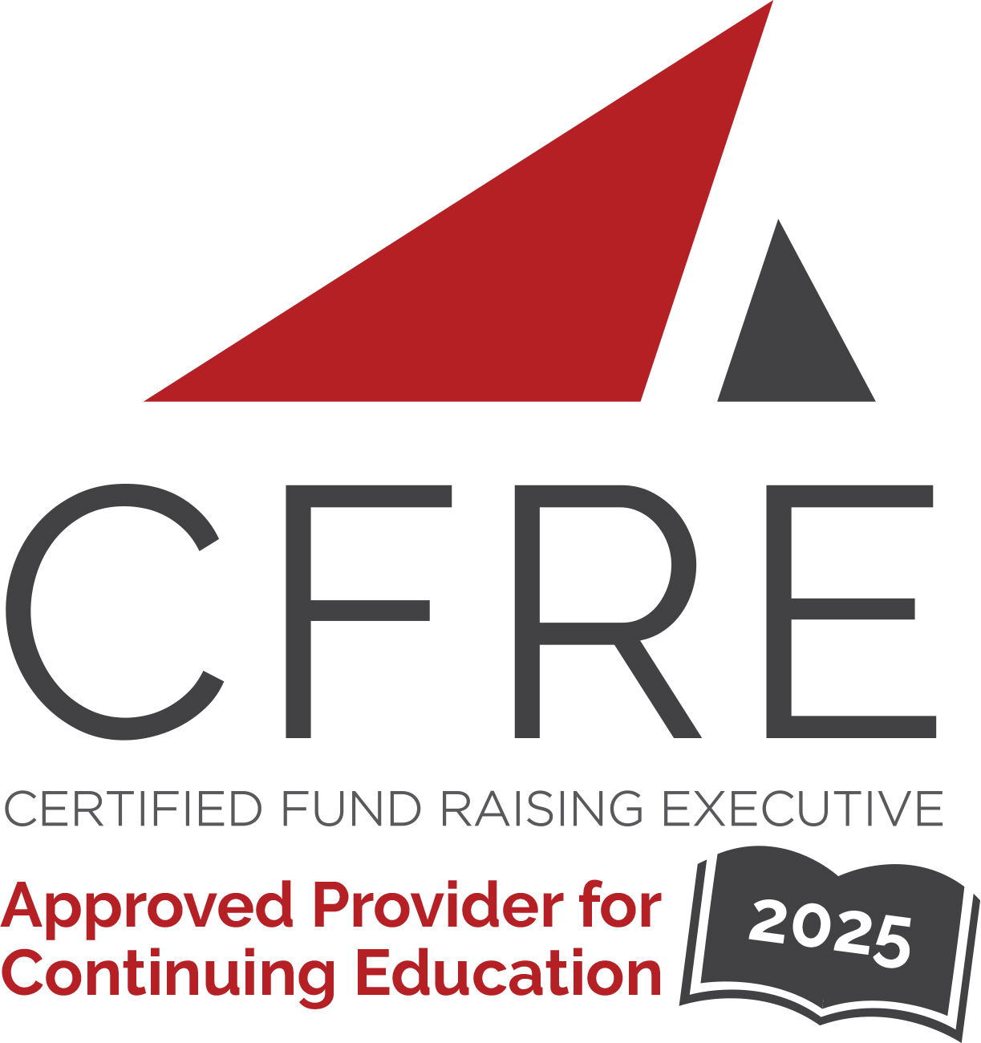  CFRE International has developed this form as a way for you to quickly track (and keep in your files!) the continuing education sessions you have attended. Simply check the boxes next to the sessions you attended. At the end of the conference, add up the total number of hours. Keep this sheet and you will be ready to complete your application form. All of the session slots listed are eligible for continuing education points on your CFRE application for initial certification and/or recertification. Sessions not listed here are not eligible for points. |  | CONTINUING EDUCATION POINTS TRACKER

Activity Organizer: - ACF
Title of Activity: - Faith and Fundraising: Myrtle Beach 2025
Names of Presenter(s): - Various
Dates and Location: - 10-13 February, 2025 – Myrtle Beach, SC USA

Date: 10 February, 2025
Session 1: 2:30pm – 4:30pm (2 pts)
- Master Class: The Case for Support Playbook – Engaging Supporters Through Salient and Sticky Stories
- Master Class: High-Net-Worth Giving – Strategies to Engage Elite Donors

Date: 10 February, 2025
Session 2: 6:00pm – 7:00pm (1 pt)
- Harnessing Your Ability to Make a Difference for Good: Keynote with Derrick Braziel

Date: 11 February 2025
Session 3: 8:15am – 9:15am (1 pt)
- Breakfast Keynote with Rebecca Bergman

Date: 11 February 2025
Session 4: 10:00am – 11:30am (1.5 pts)
- The Donor Decision Lab: How to Use Decision Science to Transform Your Fundraising with Alan Hutson and Bernard Ross

Date: 11 February 2025
Session 5: 12:00pm – 1:00pm (1 pt)
- The Future of Sustainable Giving

Date: 11 February, 2025
Session 6: 1:30pm – 3:00pm (1.5 pts)
- Decision Science Part 2 with Alan Hutson and Bernard Ross
- 4 Ways to Accelerate Your Fundraising Leadership in 2025
- Fundraising Case for Support: A Philanthropic Psychology Perspective
- Be the Exception… 7 Keys to Transformation
- Ethical Dilemma Escape Room

Date: 11 February 2025
Session 7: 3:30pm – 4:45pm (1.25 pts)
- Afternoon Keynote/Panel: The One Thing I Hate About Fundraising

Date: 12 February 2025
Session 8: 8:00am – 9:00am (1 pt)
- Breakfast Keynote with Jen Shang

Date: 12 February 2025
Session 9: 10:00am – 11:15am (1.25 pts)
- Biblical Generosity – The Heart of Faith & Fundraising
- The Rise of Micro-Moments: Capturing Donor Attention in Seconds
- Faith in Action: Digital Strategies to Grow Support and Build Community
- Event-ure Awaits: Your Journey to Successful Events Starts Here!
- The GreatCampGive: How You Can Raise $100,000 (or more!) in One Day
- Transform Your Donors From Friends to Family: Creating a Planned Giving Pipeline
- Empowering Your Non-Fundraising Staff and Volunteers: Defining Your Nonprofit’s Supporter Journey

Date: 12 February 2025
Session 10: 11:30am – 12:30pm (1 pt)
- Christian Giving in a Changing World

Date: 12 February, 2025
Session 11: 2:00pm – 3:15pm (1.25 pts)
- Hidden in Plain Sight: The Donors You Didn’t Know You Had
- Retention – Why it’s Decreasing and What to do About it
- Crush Your Ask Anxiety
- Preparing for a Major Campaign
- God’s Word, Your Mission: Embracing Scripture to Tell Your Organization’s Story
- AI-Enhanced Storytelling: Transform Communication with a Proven Framework

Date: 12 February, 2025
Session 12: 3:45pm – 5:00pm (1.25 pts)
- Story Makeover
- Donor Stewardship: Key to Sustainable Fundraising Success
- Maximizing Major Gifts: Best Practices and Tech Innovations
- Corporate Relations From the Ground Up: Building Partnerships with Those with the Big Bucks
- How to Listen for Planned Gifts
- Crafting a Seamless Executive Search Process: Steps, Strategies, and Stakeholders

Date: 12 February, 2025
Session 13: 7:00pm – 8:00pm (1 pt)
- Inspiration from Chris Singleton and The Heart of Giving: The Last-ish Supper

Date: 13 February, 2025
Session 14: 9:00am – 11:00am (2 pts)
- The Grand Finale: Rapid-Fire on the Future of Sustainable Fundraising and Panel Discussion with Thought Leaders

Total number of points attained: __________

